
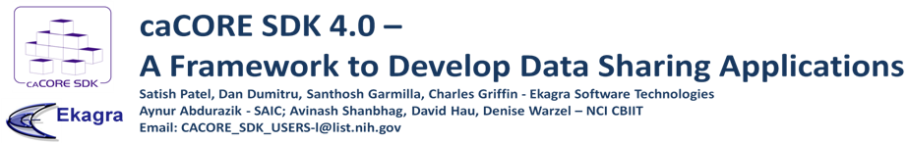
Overview

caCORE Software Development Kit (caCORE SDK) is NCI CBIIT’s tool that generates a data management framework to allow researchers to navigate through a large number of data sources. The caCORE SDK generated system is built on the principles of Model Driven Architecture (MDA), n-tier architecture and common APIs which allows for easy access to data, particularly by other applications in a secured or non secured fashion. When the caCORE SDK generated system is combined with controlled vocabularies and registered metadata, the resulting software system, called “caCORE-like” system, is “semantically integrated”. All exposed API elements have runtime accessible metadata that defines the elements using controlled terminology.

SDK System Generation Process

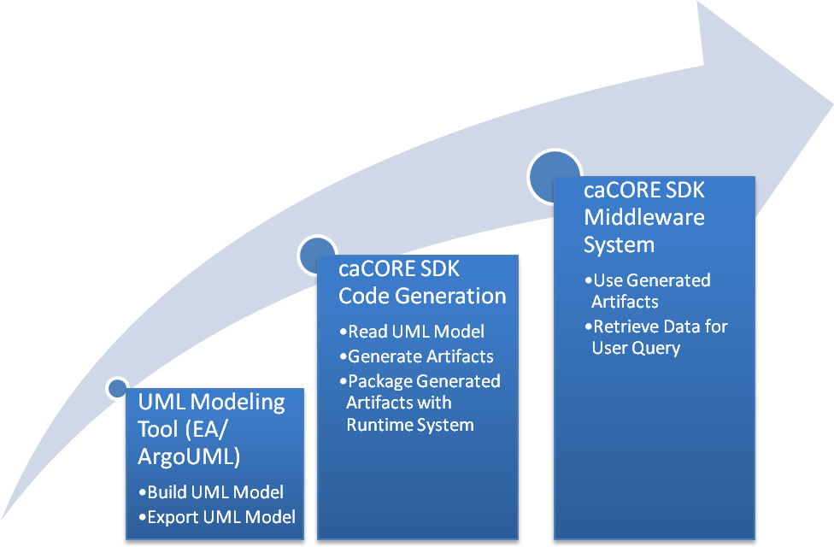 | - Build UML object model using Enterprise Architect /ArgoUML  - Build UML data model using Enterprise Architect /ArgoUML  - Export UML model in XMI/XML format  - Perform O/R mapping using caAdapter  - Configure caCORE SDK code generator  - Run the code generator  - Deploy the generated application  - Query the database against deployed application

SDK 4.0 Features

- Supports ArgoUML and Enterprise Architect for UML modeling
- Provides various interfaces to access underlying database
- Standardized Query By Example (QBE) based data access interfaces built on application’s domain model
- Ability to navigate through more than one data source
- Integrated security with Common Security Module (CSM)
- Seamless integration with the caGrid tools to create a grid service

Upcoming SDK 4.1 Features

- Fully functional writable API allowing users to edit the underlying database
- Integrated validator to implement custom validation as well as validation against the caDSR Enumerated value domains
- Integrated logging and auditing functionality with Common Logging Module (CLM)
- Enhanced O/R mapping to support primary key generators, cascade settings etc
- GME Namespace based XSD generation

Important Links

caCORE SDK : http://ncicb.nci.nih.gov/NCICB/infrastructure/cacoresdk
GForge: https://gforge.nci.nih.gov/projects/cacoresdk/
Mailing List: CACORE_SDK_USERS-l@list.nih.gov

Continued on page 2
SDK Generated Middleware System

